

MUKWA TEEPEES
#51602 – 545 Park Royal, West Vancouver, BC V7T 2X9
Authentic Anishinabe Products

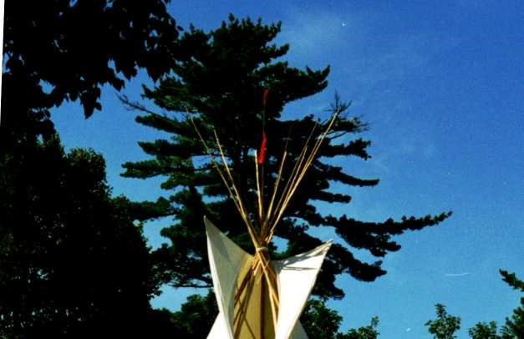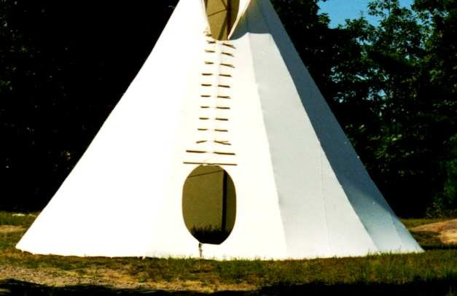

Website: www.mukwateepees.com
Email: jenny_lou@mukwateepees.com

CONFIDENTIAL QUOTE

Please note: these documents are best reviewed on a full-sized computer screen.

PRICES QUOTED ARE IN CANADIAN DOLLARS AND VALID FOR 30 DAYS WITH CURRENT INVENTORY
19 FOOT TEEPEE – COMPLETE PACKAGE - 285 Square Feet of Floor Space

This Complete Teepee Package includes everything you need to set up the Teepee and begin using it:

Teepee cover, Door, Pins, Poles, Stakes, Ropes, Storage tub, Fire Code Certificate, Five or ten year limited Warranties, Complete instructions for setting up, care and use, Certificate of Authenticity, Historical background information, Limited Money back guarantee.

YOU GET TO CHOOSE FROM THE FOLLOWING THREE FABRIC OPTIONS
100% Cotton ~ 5 year limited warranty ~ $4,295.00 each
100% Polyester ~ 5 year limited warranty ~ $5,095.00 each
100% Acrylic ~ 10 year limited warranty ~ $4,795.00 each

This quotation is valid for 30 days, measurements are all nominal and all floors are round.
No taxes apply to Native purchases which meet Revenue Canada rules. For tax exempt purchases, please include your tax exemption number or a copy of your Status Card. If this is not a tax exempt purchase, the applicable taxes will apply.

We make and keep inventory of all sizes up to 30 feet in stock ready for shipping.
Larger sized Teepees are available by special order. We would be happy to quote on any other size as you wish. For example: 40-foot diameter provides roughly 1,250 square feet of floor space. 55-foot diameter provides roughly 2,400 square feet of floor space. YES 2,400 sq ft!!

OPTIONS:

The Anishinabe Draft Skirt:
The draft skirt is for opening and closing the lower vent for heating, cooling, and air-conditioning. It is made from solution dyed acrylic canvas and is a unique option of retained tribal rights. This feature is unique to the Anishinabe Nation (and some linguistically related tribes). It was incorporated in our cultural designs long, long ago to adapt to the climate and conditions in our cultural homelands. We have modified the draft skirt for the dry land climates and for the coastal rain climates.
If you are interested, we can discuss this option further, to learn about the draft skirt’s functions and how it extends the season during which you can enjoy the comfort of your Teepee, without needing a fire or winter liner. Draft skirts are attached to the Teepee at the time of order, before we ship it.
Draft Skirt 100% Acrylic canvas ~ $895.00 each

Sub Floors:
Constructed of grass green, durable, puncture and tear resistant, heavy duty industrial fiberglass reinforced, 18 oz. vinyl tarp that lays flat and quiet during use. You can expect many years of satisfaction and quiet enjoyment from this option. Great for any wintertime location, and for rainy season use in the coastal climates. Teepees 22 feet and under have the full floor coverage except for the circumference perimeter. In Teepees 25 feet and over, it covers approximately 4/5 of the floor space, with the center area being bare for walking and for the fire. This floor is not a requirement for normal use however, many people use it as a barrier from soil moisture and put carpet on top of it, or, for keeping bedding dry. Excellent for the rainy season or for putting carpets in your Teepee! It is fire resistant material.
Sub Floor ~ $995.00 each

Winter Liners:
Here you have a choice:
Option 1) 100% Polyester Felt ~ The felt fabric is fire retardant and is a soft, olive brown color.
Option 2) 100% Cotton ~ Treated, marine canvas.
Order a liner if you plan to use your Teepee all year.
Both Options are ~ $1,495.00 each

Set-up Seminar/Workshop:
We share and teach to promote cross cultural understanding. It is important to know that our culture is not for sale. We share our Anishinabe philosophy so that you have accurate information on how to respect our traditions, and therefore understand what is acceptable and appropriate. In this way you will get the highest possible enjoyment, the greatest pleasure, and the most authentic experience with your Teepee. Tribal rights cannot be sold, nor granted by anyone.

In our full day seminar/workshop, we teach you about the care and use of your Teepee, poles and equipment.
First, we begin with a traditional Anishinabe Ceremony, unless you prefer not to. We provide some cultural teachings about etiquette and associated traditions in the Anishinabe Teepee. Clients will get to do a supervised set-up if time permits. You may have as many people/staff as you wish. In some circumstances, we can provide a meal of traditional Anishinabe corn soup if requested well enough in advance. Afterward, we are always available to you for telephone consultations.

What is included:
~ History and origins of the Teepee
~ Tribal and cultural variations of Teepees
~ Information on the details of your personal Teepee(s)
~ Site selection
~ Factors affecting the set-up of the Teepee
~ How to set-up a Teepee for short and long term camps
~ Various pole arrangements for quick set-up with only one pole, just a few poles, and NO poles
~ Detailed exercises in managing the Teepee including proper fire management and using the power flaps above and the draft skirt below for warmth, cooling, and air conditioning, in all weather conditions
~ Comfort techniques for several different weather conditions
~ Breaking camp

Full day Seminar/Workshop ~ $1,995.00 plus travel and expenses.
Indoor set-ups for this size are $395.00 extra, plus the cost of the setup kit if needed at $295.00

Small Portable wood stoves:
Our camping stoves are attractive, professional, lightweight, durable metal.
Options are:
- Horizontal round stove ~ 10” x 14” double draft with chimney pipe at only ~ $295.00 CAD
- Rectangular flat top stove with chimney pipe for ~ $395.00 CAD

Both come with removable metal legs.
Great for cooking, making hot chocolate, tea, coffee, for those chilly, early and late season conditions.

Packaging:
The Teepee cover comes in a sturdy reusable tub such as Rubbermaid roughneck, or similar depending on size. The poles are bound with reusable cinch straps, with an optional deposit refund of $200.00.

Freight:
Freight costs are not included in the Teepee price quoted. We ship with the most economical option available, within our complete transcontinental freight carrier network.
This Teepee cover will weigh about 65 pounds and with accessories, 75 pounds. The weight of the poles will be about 250 pounds.
Local delivery is ~ $350.00 CAD.
We also do custom deliveries upon request.

Ordering:
Please complete the attached order form and email it back to us. We will send a Proforma for you to confirm by email. This information is critical, because it is this confirmation that provides certainty of your order. Alternatively, we sometimes accept authorized purchase orders, for organizations who required to use them. Please follow up with a call to ensure that we have received your order.
Standard lead time is same day to a week, from payment to scheduled shipping.

Payments:
Once you have received your invoice, please send e-transfers to payments@mukwateepees.com.
If your organization uses cheques, make cheques payable to Mukwa Teepees and, mail to the address on the invoice. The cheque process may delay your teepees’ arrival time.

The table below will provide a choice of the two other sizes, with options you may be interested in:

SIZE | FABRIC | COVER | DRAFT SKIRT | SUBFLOOR | WINTER LINER | SEMINAR/  WORKSHOP
16ft | Cotton | $3295.00 | $795.00 | $895.00 | $1195.00 | $1995.00
16ft | Polyester | $3995.00 | “ | “ | “ | “
16ft | Acrylic | $3795.00 | “ | “ | “ | “
22ft | Cotton | $4995.00 | $995.00 | $1195.00 | $1595.00 | $1995.00
22ft | Polyester | $6195.00 | “ | “ | “ | “
22ft | Acrylic | $5895.00 | “ | “ | “ | “

If you are interested in one of the two other size options in the table above, we can provide you with further details as needed. Thank you!

We also make Sweat Lodge Covers, Wigwam Covers and Shaboutans (Long Lodges).
Just ask for a quote if you are interested.

We reserve all rights to our products.

We urge people to use authentic native products, whomever they choose to purchase from.
Enjoy your Teepee; we wish you the greatest pleasure, health, and joy in your teepee!

Thanks sincerely,
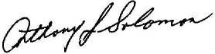
Tony Solomon (Giwise Inini)

* Sale of our Teepees does not include any of the above inherent or implied rights, intellectual rights and cultural property rights protected by law. Our Teepees may not be used for copying, modifying, and/or manufacturing of this Teepee style without our express written permission, to the extent we can grant it. Some rights are Anishinabe tribal rights and cannot be sold nor granted.

Tel: (604) 727-4340 Website: www.mukwateepees.com Email: jenny_lou@mukwateepees.com

End.
Q1925

